An Integrated Business Intelligence for Sales Forecasting and Inventory Management

A Capstone Project Presented to the Faculty of
Institute of Computing Studies and Library Information Science
City College of Angeles
Angeles City



In Partial Fulfillment of the Requirement for the Degree
Bachelor of Science in Information Systems

By:

Clark Justine T. Basco
Christian M. Cunan
Harold P. Dalusung
Halden H. Niguidula
Adrian Jury C. Pineda
Frederick Matthew Y. Pineda

March 2026
APPROVAL SHEET
This Capstone entitled â€œAN INTEGRATED BUSINESS INTELLIGENCE FOR SALES FORECASTING AND INVENTORY MANAGEMENTâ€ prepared and submitted by:
Clark Justine T. Basco
Christian M. Cunan
Harold P. Dalusung
Halden H. Niguidula
Adrian Jury C. Pineda
Frederick Matthew Y. Pineda
In partial fulfillment of the requirements for the degree Bachelor of Science in Information Systems, has been examined and is recommended for acceptance and approval for Oral Examination.
Insert Name Here
Thesis Instructor
Insert Name Here
Adviser
CAPSTONE COMMITTEE
After having been presented is hereby accepted by the Committee on Oral Examination towards the fulfillment of the requirements for the Degree of Bachelor of Science in Information Systems.
Insert Name Here
Chairman
Insert Name Here
Member
Insert Name Here
Member
Noted by:
Insert Name Here
Program Coordinator, BSIS
Insert Name Here
Dean, ICSLIS

ACKNOWLEDGEMENT
The researchers offer their deepest gratitude and praise to Almighty God for bestowing wisdom, perseverance, good health, and spiritual resilience throughout the arduous journey of conducting this research and engineering the capstone system prototype. Without divine grace and providence, the completion of this scholarly undertaking would not have been possible.
Profound and heartfelt appreciation is respectfully expressed to our Capstone Adviser and Thesis Instructor for their invaluable technical mentorship, academic guidance, constructive criticisms, and relentless encouragement. Their rigorous standards and unwavering commitment to excellence steered the formulation of our system architecture and the empirical integrity of this manuscript. We likewise convey our sincere gratitude to the Dean, Program Coordinator, and esteemed Faculty Members of the Institute of Computing Studies and Library Information Science (ICSLIS) at City College of Angeles for cultivating an intellectually enriching academic environment.
The researchers convey their heartfelt respect, gratitude, and empathy to the management, staff, and proprietors of Sharon Store in the Pampang Public Market, Angeles City. Although a tragic and devastating fire incident destroyed the physical establishment on September 16, 2026, their prior generosity, transparency, and collaboration during preliminary operational field interviews and workflow assessments laid the foundational groundwork for understanding retail grocery inventory and sales vulnerabilities. Special thanks are also extended to the three independent Information Technology experts and retail grocery evaluators across Angeles City who devoted their professional time and expertise to rigorously evaluate the system prototype in accordance with the ISO/IEC 25010 Software Quality Standard. Finally, our warmest love, gratitude, and devotion go to our beloved parents, families, friends, and colleagues for their constant prayers, moral encouragement, and financial sacrifices.

TABLE OF CONTENTS
APPROVAL SHEET ii
ACKNOWLEDGEMENT iii
TABLE OF CONTENTS iv
LIST OF TABLES vii
LIST OF FIGURES viii
ABSTRACT 1
INTRODUCTION 3
Background of the Study 3
Statement of the Problem 5
Objectives of the Study 6
Scope of the Study 7
Delimitations of the Study 9
Conceptual Framework 10
Significance of the Study 11
Definition of Terms 13
Ethical Considerations 14
REVIEW OF RELATED LITERATURE AND STUDIES 16
Foreign Literature 16
Local Literature 17
Foreign Studies 18
Local Studies 19
The Research Gap 21
Synthesis and Relevance to the Current Study 21
METHODOLOGY 23
Research Design 23
System Development Methodology 24
Participants 29
Sampling Method 30
Procedure 32
Data Analysis 35
Design and Implementation 36
Requirements Specification Analysis 36
System Design and Specifications 38
Logical Specifications 39
Hardware Specifications 40
Software Specifications 41
RESULTS 44
System / Application Outputs 44
Evaluation Results 46
DISCUSSION 50
Summary of Findings 50
Conclusions 51
Recommendations 52
REFERENCES 54
APPENDICES 59
Appendix A: Adviser’s Commitment and Agreement 59
Appendix B: Letter of Approval to Conduct Capstone Project 61
Appendix C: Interview Questions 62
Appendix D: Evaluation Tool (Non-IT) 64
Appendix E: Evaluation Tool (IT Experts) 66
Appendix F: Data Flow Diagram Level 0 68
Appendix G: Data Flow Diagram Level 1 69
Appendix H: Use Case Diagram 69
Appendix I: Entity Relationship Diagram 70
Appendix J: System Flowchart 70
Appendix K: Documentation of the Research Locale 71

LIST OF TABLES
Table 1. Likert Scale 35
Table 2. Score Interpretation 36
Table 3. Hardware Specification Table 40
Table 4. Software Specification Table 41
Table 5. Summary of ISO/IEC 25010 Evaluation Results (IT Experts) 47
Table 6. Summary of ISO/IEC 25010 Evaluation Results (Non-IT Users) 48
Table 7. Overall Composite Software Quality Evaluation Summary 48

LIST OF FIGURES
Figure 1. IPO Conceptual Framework Diagram 10
Figure 2. Agile Development Methodology Model 24
Figure 3. Business Intelligence (BI) Analytics Dashboard Output 44
Figure 4. Sales Forecasting Module Output (SMA & WMA) 45
Figure 5. Inventory Management and Stock Alert Interface Output 45
Figure 6. Point of Sale (POS) High-Speed Barcode Checkout Interface Output 45
Figure 7. Cashier Shift Management and Cash Reconciliation Output 46
Figure 8. Automated Cloud Database Backup and Disaster Recovery Output 46
ABSTRACT
This capstone project presents an Integrated Business Intelligence for Sales Forecasting and Inventory Management system developed for small and medium retail grocery enterprises in Angeles City, Pampanga, originating from the operational baseline of Sharon Store. Prompted by systemic vulnerabilities and the catastrophic September 16, 2026 fire incident that destroyed the initial establishment's physical records, the study addresses critical operational bottlenecks, inventory inaccuracies, stockout risks, and financial losses resulting from manual pen-and-paper ledgers. Employing the Agile Development Methodology, the researchers engineered a resilient dual-deployment web platform featuring an interactive Business Intelligence dashboard powered by Chart.js, quantitative time-series sales forecasting using Simple Moving Average (SMA) and Weighted Moving Average (WMA), rapid Point of Sale (POS) checkout processing with USB/Bluetooth barcode scanning and thermal receipt printing, cashier shift cash reconciliation, and automated Google Drive cloud backups under a 5-version rolling retention policy. Built on PHP 8.2, MySQL with SSL encryption, and the Vercel serverless platform, the system incorporates database-backed session handling across distributed lambdas. Due to the destruction of the initial locale, Convenience Sampling was utilized to engage accessible grocery store managers, cashiers, and retail shoppers across Angeles City commercial districts for operational usability trials, while Purposive Sampling engaged three IT experts for technical validation using the ISO/IEC 25010 Software Quality Standard. The system provides local grocery enterprises with data-driven procurement capabilities, continuous cloud disaster resilience, and inventory waste reduction in alignment with the City College of Angeles Research Agenda and UN Sustainable Development Goals.
Keywords: Business Intelligence, Sales Forecasting, Inventory Management, Point of Sale, Moving Average, Cloud Resilience, ISO/IEC 25010.

INTRODUCTION

Background of the Study
Technology is constantly evolving, and the retail business sector is no exception. In the modern globalized economy, the transition from traditional, manual operations to digitized frameworks is no longer a luxury but a competitive necessity. To address these global operational challenges, the United Nations established the Sustainable Development Goals (SDGs), specifically highlighting SDG 9 (Industry, Innovation, and Infrastructure), which emphasizes the need to upgrade the technological capabilities of enterprises, and SDG 12 (Responsible Consumption and Production), which targets the reduction of retail waste and commercial spoilage (United Nations, 2024). Globally, enterprises handling fast-moving consumer goods (FMCG) are shifting toward data-driven inventory management to prevent overstocking and minimize financial losses from expired products (F1000Research, 2024).
In the Philippines, local grocery stores operating within bustling public markets play a vital role in sustaining community economies. However, many of these small and medium enterprises (SMEs) still rely heavily on traditional pen-and-paper methods for their daily operations (Asian Development Bank, 2025; Department of Trade and Industry, 2024). The manual recording of hundreds of daily transactions involving canned goods, dry commodities, and household essentials is highly prone to human error. Without a centralized system to track fast-moving items and monitor approaching expiration dates, these traditional businesses often suffer from inaccurate stock counts, leading to unexpected stockouts of high-demand products and the costly disposal of expired goods (Villanueva & Reyes, 2025).
This operational gap was acutely evident at Sharon Store, a retail grocery establishment located in the Pampang Public Market, Angeles City, Pampanga. Operating since 2017 with an operational workforce of 8 employees and 2 managing owners, the enterprise previously conducted its daily inventory management and high-volume grocery transactions using manual pen-and-paper logbooks. This traditional practice severely restricted management's ability to maintain real-time inventory visibility, monitor perishable product expiration dates, or accurately forecast consumer demand for daily staples. However, on September 16, 2026, a catastrophic fire incident broke out within the public market, which tragically destroyed the physical establishment of Sharon Store. This unforeseen disaster underscored the profound systemic vulnerabilities of micro and small enterprises that rely entirely on on-premise physical records and unbacked localized hardware, which are irrecoverably lost in the event of physical calamities.
In response to these critical operational realities and real-world vulnerabilities, this capstone project delivers an Integrated Business Intelligence for Sales Forecasting and Inventory Management system. Designed with modern architectural resilience, the system transitions retail grocery operations from fragile manual ledgers to an automated, cloud-enabled web platform featuring Point of Sale (POS) checkout processing, real-time Business Intelligence analytics, predictive time-series sales forecasting, and automated offsite cloud database backups. By integrating dynamic store configuration parameters, the system empowers local grocery retailers across Angeles City to make data-driven procurement decisions, minimize commercial waste, and maintain seamless business continuity regardless of localized disruptions.

Statement of the Problem
The study seeks to address the operational, technical, and business continuity vulnerabilities arising from traditional manual inventory and sales management practices among small and medium enterprise (SME) retail grocery stores in Angeles City, Pampanga, using Sharon Store as the initial baseline establishment. Specifically, it aims to answer the following research questions:
1. What are the operational challenges and systemic vulnerabilities encountered by retail grocery establishments in managing manual inventory tracking, physical logbook sales recording, and cash drawer reconciliations?
2. How can an interactive Business Intelligence (BI) dashboard and a quantitative time-series forecasting engine (Simple Moving Average and Weighted Moving Average) be designed to optimize stock procurement and mitigate losses from expired perishable merchandise?
3. How can a cloud-resilient web architecture featuring dual local/serverless deployment, database-backed sessions, and automated Google Drive offsite backups be engineered to ensure continuous business operations against physical calamities?
4. How acceptable and technically sound is the developed system when evaluated by SME grocery owners/managers, operational cashiers, retail customers, and IT experts in accordance with the ISO/IEC 25010 Software Quality Model?

Objectives of the Study
The general objective of the study is to design, develop, and implement an Integrated Business Intelligence for Sales Forecasting and Inventory Management system for retail grocery enterprises in Angeles City, Pampanga (originating from the baseline operational requirements of Sharon Store), providing real-time data analytics, automated time-series sales forecasting, high-speed Point of Sale (POS) checkout processing, shift cash reconciliation, and resilient cloud database backups.
Specifically, the study aims to achieve the following specific objectives:
1. To construct an interactive Business Intelligence (BI) Dashboard utilizing Chart.js v4.4.x to visualize daily sales curves, gross revenue metrics, fast-moving consumer items, and critical low-stock indicators.
2. To implement a quantitative Sales Forecasting Module employing Simple Moving Average (SMA) and Weighted Moving Average (WMA) algorithms across 7-day, 14-day, and 30-day forecast horizons to compute automated product replenishment quantities.
3. To develop an Inventory Management Module supporting multi-category classification, batch expiration date tracking, multi-unit stock levels (pieces, packs, kilograms), and status-based inventory sorting.
4. To engineer a high-speed Point of Sale (POS) Module integrated with plug-and-play USB/Bluetooth barcode scanners, automated item calculations, Senior Citizen and PWD statutory discount applications, change computation, atomic inventory stock deduction, and thermal receipt generation.
5. To establish a Cashier Shift Management and Cash Reconciliation Module enabling frontline workers to log opening cash floats, record mid-shift adjustments, and complete closing cash drawer reconciliations with automated discrepancy computations.
6. To build an Automated Cloud Database Backup Module utilizing a pure-PHP backup engine synchronized with the Google Drive API under a 5-version rolling retention policy.
7. To implement a secure, multi-role user management architecture supporting Role-Based Access Control (Admin, Manager, Cashier), cashier registration approval workflows, and immutable audit logging.
8. To evaluate the technical quality, functional suitability, usability, and performance efficiency of the developed system against the ISO/IEC 25010 Software Quality Standard.

Scope of the Study
This study focuses on the design, development, and implementation of an Integrated Business Intelligence for Sales Forecasting and Inventory Management system. While the research was initially conceptualized and operationalized around the baseline requirements of Sharon Store at the Pampang Public Market, Angeles City, Pampanga, the project's architectural scope was strategically adapted following the September 16, 2026 fire incident that destroyed the initial establishment. The system was transformed into an agile, highly configurable web platform designed for small and medium retail grocery enterprises within Angeles City, supporting both offline-first local market workflows and cloud-enabled multi-terminal accessibility. The implementation and evaluation of the system occur across the academic cycle, focusing on functional suitability, usability, performance efficiency, data security, and stakeholder satisfaction based on the ISO/IEC 25010 software quality model.
The functional modules provided by the system are structured across administrative and operational roles. For the System Administrator or Owner, the application provides an interactive Business Intelligence (BI) Dashboard Module equipped with dynamic Chart.js visualizations that track real-time gross revenue, daily transaction volumes, fast-moving consumer items, and critical stock alerts. It incorporates a Sales Forecasting Module utilizing time-series quantitative analytics (Simple Moving Average and Weighted Moving Average over 7-day, 14-day, and 30-day forecast horizons) to project future product demand and generate automated restocking recommendations. The Inventory Management Module provides full control to categorize grocery items (canned goods, dry commodities, household essentials), track batch expiration dates, and monitor stock balances across varied packaging units. Additionally, the administrative suite includes a Suppliers Management Module to maintain distributor directories and procurement histories, a Cashier Shift Audit and Cash Reconciliation Module to oversee shift floats, mid-shift drops, drawer counts, and cash variance discrepancies, a Comprehensive Reports Generation Module offering customizable date-range filtering and exportable operational summaries, and an Automated Cloud Database Backup Module synchronized with Google Drive API utilizing a 5-version rolling retention policy.
For the Operational Staff, the system delivers a streamlined Point of Sale (POS) Module integrated with plug-and-play USB and wireless Bluetooth barcode scanners. This serves as a rapid checkout interface that scans items, calculates invoice subtotals, applies statutory Senior Citizen and PWD discounts, computes cash change, and automatically triggers atomic inventory stock deductions upon confirmed purchase completion, with support for 58mm and 80mm thermal receipt printing. Furthermore, the Cashier Shift Management Module allows frontline staff to declare initial cash floats, record mid-shift cash-in/out adjustments, and complete closing cash drawer reconciliations with automated discrepancy calculations.

Delimitations of the Study
To maintain strict alignment with Information Systems principles and ensure practical project feasibility, the system boundaries explicitly define functional and technical parameters. In terms of hardware peripherals, the system is designed to interface with plug-and-play USB and wireless Bluetooth barcode scanners (1D/2D EAN-13, UPC-A) and standard POS thermal receipt printers (58mm and 80mm ESC/POS format) to expedite the checkout process. The system explicitly excludes integration with proprietary electronic cash drawer solenoid triggers, biometric time-and-attendance clocks, and physical anti-theft tagging sensors (such as RFID security gates or smart CCTV video analytics). Regarding business operations, the application is strictly scoped to retail inventory, Point of Sale transactions, cashier shift reconciliation, and quantitative forecasting; it completely excludes enterprise human resources payroll calculations, official BIR electronic tax portal filings, and customer-facing e-commerce delivery logistics. Furthermore, regarding procurement, while the system calculates automated restocking recommendations, it does not autonomously execute financial purchase orders; store management retains manual control to negotiate wholesale vendor pricing and inspect physical merchandise. Finally, concerning predictive analytics, the forecasting module relies solely on historical internal transaction logs and does not autonomously predict macroeconomic anomalies such as sudden hyperinflation, national supply disruptions, or emergency panic buying during natural disasters.

Conceptual Framework
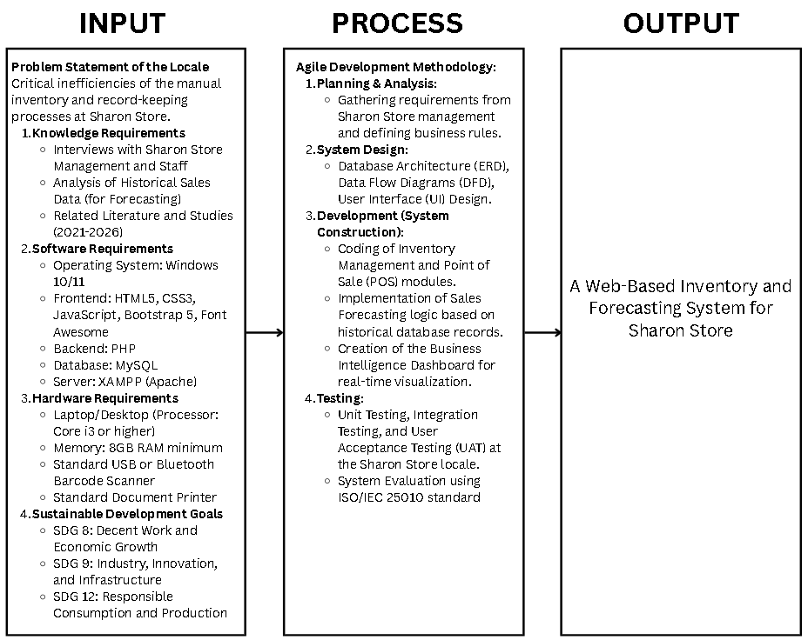
Figure 1. IPO Diagram
The Input phase identifies the foundational requirements of the study, including the current manual inventory processes, historical sales data, and necessary hardware and software. The Process phase follows the Agile Development Methodology, working through iterative cycles of requirements planning, system design, system construction, and rigorous testing utilizing the ISO/IEC 25010 standard. Finally, the Output phase delivers the fully functional, web-based digital solution designed to drive operational innovation and economic growth for the enterprise.

Significance of the Study
The development of this Integrated Business Intelligence for Sales Forecasting and Inventory Management system provides transformative operational, economic, and technological benefits to multiple stakeholder groups, while directly aligning with institutional, national, and global development agendas:
Alignment with the City College of Angeles (CCA) Research Agenda: Guided by CCA's mission to serve as an agent of community progress and economic resilience in Angeles City, this research addresses local commercial challenges by empowering micro, small, and medium retail grocery enterprises (MSMEs) with accessible, enterprise-grade business intelligence. It embodies the college's core values of Stewardship and Resiliency by transforming the physical adversity of the Sharon Store fire into an opportunity for scalable cloud technological advancement that strengthens the local economic fabric.
Alignment with United Nations Sustainable Development Goals (UN SDGs): The study directly advances three global goals: (a) SDG 8 (Decent Work and Economic Growth) by supporting MSME productivity, modernizing frontline retail workflows, and safeguarding small commercial enterprises against catastrophic data loss; (b) SDG 9 (Industry, Innovation, and Infrastructure) by upgrading the technological capabilities of traditional market retailers through cloud-resilient serverless infrastructure and visual analytics; and (c) SDG 12 (Responsible Consumption and Production) by drastically mitigating perishable grocery spoilage and commercial food waste through proactive batch expiration tracking and quantitative moving average restocking forecasts.
Alignment with National and Sectoral Agendas: The project actively supports the Department of Trade and Industry (DTI) Inclusive Innovation Industrial Strategy (i3S) by promoting MSME digital transformation and supply chain optimization, the Department of Science and Technology (DOST) Harmonized National R&D Agenda (HNRDA) by applying emerging web technologies to commercial problem-solving, and the National Economic and Development Authority (NEDA) Philippine Development Plan (PDP) by fostering economic innovation among local trade establishments.
To the SME Grocery Owners and Managers: It delivers real-time visibility into sales revenues, profit margins, and inventory health via the Business Intelligence Dashboard, eliminates capital tie-up from overstocking, prevents stockouts of high-demand staples, and guarantees offsite data protection through automated Google Drive backups.
To the Frontline Operational Staff (Cashiers): It accelerates checkout transactions through rapid barcode scanning, automates discount and change computations, removes the burden of manual pen-and-paper transaction logging, and streamlines shift cash drawer reconciliations.
To the Retail Customers (Shoppers): It ensures consistent shelf availability of daily household necessities, minimizes checkout queue wait times, and provides clear, professional thermal receipts.
To the Local Economy of Angeles City: It contributes to the digital modernization and financial resilience of neighborhood retail grocery stores, fostering economic stability across local public market communities.
To the Researchers and Future Researchers: It serves as a rigorous, practical reference framework for designing cloud-resilient business intelligence and time-series forecasting applications tailored for micro and small retail enterprises in developing economies.

Definition of Terms
Business Intelligence (BI) Dashboard - Refers to the visual analytics interface within the system powered by Chart.js v4.4.x that renders real-time graphical charts, revenue metrics, fast-moving items, and critical stock level indicators to assist managerial decision-making.
Sales Forecasting Module - Refers to the quantitative predictive analytics engine that processes historical transaction logs using Simple Moving Average (SMA) and Weighted Moving Average (WMA) models across 7-day, 14-day, and 30-day horizons to generate automated product replenishment recommendations.
Inventory Management - Refers to the core system module that tracks product quantities, categorizes grocery goods, monitors packaging units, and records batch expiration dates to minimize product spoilage.
Point of Sale (POS) - Refers to the rapid checkout interface that interfaces with USB/Bluetooth barcode scanners, calculates item subtotals, applies statutory Senior Citizen and PWD discounts, computes cash change, executes atomic inventory deductions, and produces 58mm/80mm thermal receipts.
Cashier Shift Reconciliation - Refers to the formal accounting workflow wherein cashiers declare opening cash floats, log mid-shift adjustments, and record closing cash drawer counts to compute variance discrepancies (overages or shortages) automatically.
Cloud Disaster Recovery & Rolling Backup - Refers to the automated pure-PHP database backup engine integrated with the Google Drive API under a 5-version rolling retention policy, ensuring offsite data preservation and business continuity without operating system binary dependencies.
Role-Based Access Control (RBAC) - Refers to the security mechanism that partitions administrative privileges and operational duties across distinct user roles (Admin, Manager, and Cashier), supplemented by an approval workflow for pending cashier accounts.
ISO/IEC 25010 Software Quality Standard - Refers to the international evaluation framework used to assess the system across eight quality characteristics: Functional Suitability, Performance Efficiency, Compatibility, Usability, Reliability, Security, Maintainability, and Portability.
Ethical Considerations
To maintain the highest standards of scientific integrity, academic honesty, and ethical responsibility, the researchers observed comprehensive ethical safeguards throughout the conduct of this study, in full alignment with the City College of Angeles research guidelines:
1. Voluntary Participation and Informed Consent: All participants in this study-including SME grocery store owners, retail managers, operational cashiers, and grocery shoppers-were provided with comprehensive explanations regarding the objectives, procedures, and scope of the research. Participation was strictly voluntary, and respondents were informed of their explicit right to withdraw from usability trials or surveys at any point without prejudice or operational consequence.
2. Confidentiality and Compliance with Data Privacy (Republic Act No. 10173): In strict accordance with the Philippine Data Privacy Act of 2012, all proprietary retail records, sales revenues, wholesale supplier prices, and customer purchasing details extracted during data gathering were treated with rigorous confidentiality. All personal identifying information was anonymized, and system evaluation metrics were reported purely in statistical aggregates. Database backups and access credentials were encrypted to protect stakeholder commercial data.
3. Disaster Sensitivity and Compassionate Stakeholder Engagement: In light of the devastating September 16, 2026 fire that destroyed the physical premises of Sharon Store, the researchers exercised utmost sensitivity, empathy, and respect toward the affected proprietors and staff. Prototype demonstrations were conducted without imposing operational burdens on the recovering establishment, and usability trials were ethically extended to accessible retail grocery peers across Angeles City.
4. Academic Honesty and Software Licensing Integrity: All third-party software frameworks, client-side libraries (Bootstrap v5.3.0, Font Awesome v6.5.0, Chart.js v4.4.x, SweetAlert2 v11.x), runtime extensions (vercel-php), and academic literature incorporated into the study are properly attributed in accordance with APA 7th Edition standards and utilized in full compliance with their respective open-source licensing terms (MIT and Apache 2.0 licenses).
5. Beneficence and Operational Non-Maleficence: Prototype evaluations and barcode scanner demonstrations were designed and scheduled during non-peak retail hours to prevent disruption to daily market transactions, customer checkout queues, or financial cash drawer handling.

REVIEW OF RELATED LITERATURE AND STUDY

Foreign Literature
Ladani et al. (2025) discuss the basic structure of web-based inventory and warehouse management systems, particularly the importance of real-time database synchronization for accurate stock monitoring. This is relevant to Sharon Store because the store plans to move from traditional paper-based logbooks to a more organized and automated digital inventory system.
Adetula and Akanbi (2023) emphasize the importance of using predictive analytics to maintain proper inventory levels in small and medium-sized businesses. While Sharon Store will use historical sales data and statistical methods instead of advanced AI, the idea of using data to recommend the right amount of stock can still help prevent overstocking, especially for perishable grocery products.
Ghosh et al. (2022) discuss the use of Business Intelligence (BI) dashboards to present sales trends and important inventory information in an easy-to-understand way. Applying this concept to Sharon Store can help transform its manual inventory records into a more organized digital system while also supporting innovation in small businesses, which is consistent with Sustainable Development Goal 9.
Finally, Kumar and Sharma (2024) analyze modern organizational inventory control frameworks for retail supply chains. Their findings emphasize that establishing strict categorization, batch tracking, and real-time monitoring mechanisms for fast-moving consumer goods and dry commodities directly mitigates commercial stockouts and waste, providing contemporary empirical support for Sharon Store's inventory tracking module.
Agboola et al. (2022) show that web-based inventory systems can reduce errors caused by manual recording and improve how resources are managed in small businesses. Their findings support the use of a digital database for local retail stores like Sharon Store to make inventory tracking more accurate and efficient.

Local Literature
Tanaman et al. (2023) highlight the importance of web-based inventory management systems in improving supply chain operations in the Philippines. Their work supports the use of simple and accessible web-based systems for local businesses and vendors that need better ways to manage their inventory.
Bautista and Young (2022) examine inventory management practices in the Philippine food and seasoning industries. They emphasize that proper and systematic stock monitoring can improve the efficiency of product supply and distribution, which is also important for small grocery stores.
German (2016) discusses the shift from traditional inventory monitoring to mobile Point of Sale (POS) applications connected to cloud-based inventory systems. This shows how cloud technology can help micro and small businesses in the Philippines improve their daily operations and keep their inventory records more organized.
Furthermore, Mendoza and Santos (2023) examine contemporary digital transformation among Philippine micro and small enterprises, establishing that transitioning from manual logbooks to streamlined web-based inventory and transaction architectures significantly enhances data integrity, operational transparency, and transaction processing speeds in local public market retail ecosystems.
The Ilocos Norte Healthcare Study (2022) examined inventory management practices and their effect on service delivery in local facilities. The study showed that having an organized system for monitoring supplies can improve overall operational performance, which can also be applied to other types of local establishments.

Foreign Studies
Nicholas et al. (2025) developed and evaluated a website-based inventory system designed for grocery stores. Their study showed that digital inventory tracking can reduce duplicate records and human errors that commonly occur when businesses rely on paper-based recording.
Permatahati and Muqorobin (2022) developed a web-based sales forecasting system using the Single Moving Average method. Their study demonstrated that historical sales records can be analyzed to identify patterns and estimate future product demand.
Amuharnis et al. (2026) developed an inventory forecasting system for Tita's Store using the Weighted Moving Average method. Their study showed that historical sales information can be used to support better restocking decisions in grocery businesses.
Subianto et al. (2023) developed a web-based cashier and inventory system for MSMEs using a prototyping approach. Their study showed that connecting the POS system with inventory records allows sold products to be automatically deducted from the available stock, making transactions faster and inventory updates more convenient.
Nasution et al. (2023) used the Least Square method in a web-based sales forecasting system. Their study demonstrated that mathematical forecasting techniques can be integrated into information systems to help businesses estimate future demand and make better restocking decisions.

Local Studies
Suya et al. (2026) developed "Sort Out," a smart inventory management system that uses descriptive analytics and rule-based algorithms for mini grocery stores. Their study is closely related to Sharon Store because it demonstrates how a simple data-driven system can help small grocery businesses manage their inventory more effectively.
Custodio et al. (2026) developed a predictive sales and inventory system that also included customer segmentation. Their study showed that combining sales forecasting with inventory management can improve retail operations and help businesses make better decisions based on customer and sales data.
Bonto et al. (2025) developed "Sentimart," a web-based system that combines ordering, inventory management, and customer feedback. Their study demonstrates how several business functions can be brought together in one web-based platform to make business operations more organized and efficient.
Panganiban and Bermusa (2020) designed a barcode-based POS and inventory system with replenishment decision support. Their study showed that barcode scanners can provide an affordable way for local stores to improve checkout speed while also making inventory monitoring easier.
Maglinte et al. (2025) applied a systems engineering approach to develop an integrated POS and inventory system for a food court. Their study showed that automatically synchronizing transaction records with inventory information can improve efficiency, especially in businesses where transactions happen quickly and frequently.

The Research Gap
Although many local and foreign studies have explored inventory management, sales forecasting, and POS systems, there is still a gap when it comes to the specific needs of small public market grocery stores in the Philippines, such as Sharon Store in the Pampang Public Market.
Many foreign studies, including those by Ladani et al. (2025), Adetula and Akanbi (2023), and Agboola et al. (2022), focus on larger businesses or systems that may require more advanced equipment and infrastructure. Similarly, studies such as Nicholas et al. (2025) and Subianto et al. (2023) often present systems designed for businesses with more complete POS setups.
Local literature and studies, such as German (2016), Bautista and Young (2022), Custodio et al. (2026), and Maglinte et al. (2025), also provide useful solutions, but many of these systems are designed for formal stores, mini-marts, or larger business environments. These systems may involve additional hardware such as receipt printers, customer displays, cash drawers, or more advanced forecasting technologies.
Because of this, there is still a need for a simple and affordable inventory and sales forecasting system specifically designed for traditional public market stores. Vendors in these environments need a system that can make transactions faster, monitor inventory accurately, and provide useful restocking recommendations without requiring expensive hardware or complicated machine learning technologies.

Conclusion
The reviewed literature and studies show that moving from paper-based inventory records to a web-based system can greatly help small businesses improve their daily operations. Foreign studies such as Nicholas et al. (2025), Permatahati and Muqorobin (2022), and Amuharnis et al. (2026), together with local studies such as Suya et al. (2026) and Panganiban and Bermusa (2020), demonstrate that combining digital transaction records with statistical forecasting can help reduce inventory errors, stockouts, and overstocking.
Based on these synthesized empirical findings, this capstone project addresses the identified operational and technological gaps by developing an Integrated Business Intelligence for Sales Forecasting and Inventory Management system. Designed with practical resilience for small and medium retail grocery enterprises within Angeles City, Pampanga (originating from the operational baseline of Sharon Store), the system bridges the divide between costly enterprise-grade ERPs and fragile manual logbooks by combining low-cost barcode-driven POS transactions, client-side visual analytics, time-series forecasting, and automated offsite cloud backups.
To keep the system affordable, it will only require a standard plug-and-play barcode scanner for faster product identification and checkout. It will not depend on expensive POS peripherals such as receipt printers or automated cash drawers. In addition, the system will use historical sales data and simple statistical forecasting methods, such as Moving Averages, to provide practical restocking recommendations. In this way, the proposed system offers Sharon Store a simple, affordable, and appropriate digital solution for improving inventory management and reducing the problems associated with manual recording.

METHODOLOGY
This section identifies the methods and activities that will be performed in order to accomplish the project or the specified objectives. It typically includes sections on the sample of participants and how they were obtained, instrumentation used, step-by-step procedures in gathering and processing data, design and statistical treatment of data. Activities in system methodology are also discussed which cover from problem identification throughout the development and implementation of the project.

Research Design
This study will utilize a Descriptive Research Design. Descriptive research is appropriate when the goal is to understand the current state of a system, group, or process: what is happening now. Employing a descriptive method is practical and relevant for this project because the proposed software system must fit the existing business operations of Sharon Store. This design will enable the researchers to capture an accurate baseline of how the current manual grocery operations run, identifying existing pain points and objectives before attempting to implement the web-based system. This baseline will be captured through interactive approaches, such as interviews with the store management, and unobtrusive methods, such as direct observation of the checkout workflow and reviewing existing physical logbooks.

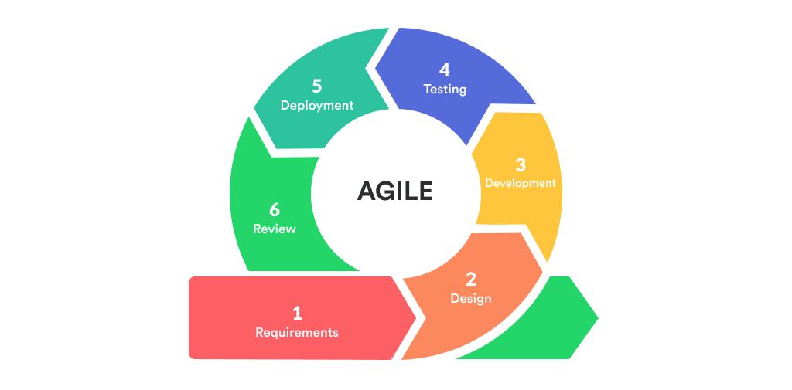
Systems Development Methodology
Figure 2. Agile Methodology
Agile Development Methodology
The researchers will utilize the Agile methodology for this capstone project (Schwaber & Sutherland, 2020). Agile is an iterative approach to software development that delivers work in small, manageable increments called sprints. It emphasizes collaboration, flexibility, and continuous feedback, allowing teams to adapt to changing requirements throughout the project.
Agile was selected because the system requires regular user feedback from the Sharon Store management regarding the Point of Sale (POS) interface and inventory workflows. By utilizing short cycles and constant communication, the system can receive continuous feedback for further improvements and refinements, ensuring that the final checkout and forecasting modules perfectly align with the fast-paced nature of the public market.
Requirement & Analysis
This phase begins with establishing definitive system requirements using operational data acquired from structured interviews with retail grocery owners, operational cashiers, and grocery market stakeholders across Angeles City, combined with direct observations of manual retail workflows. The technical analysis translates these operational bottlenecks into robust software and hardware specifications. On the software tier, the system employs a dual-deployment architecture: an offline-first XAMPP stack (Apache server, PHP 8.2+, MySQL) for localized execution, and the Vercel Serverless Cloud Platform (utilizing the vercel-php v0.7.2 serverless runtime, edge routing, and custom vercel.json configurations) paired with a remote MySQL / MariaDB relational database secured through SSL certificate authentication (cacert.pem). Frontend development is built on HTML5, CSS3, JavaScript (ES6+), Bootstrap 5.3.0, Font Awesome 6.5.0, Chart.js v4.4.x for client-side visual analytics and forecasting curve rendering, and SweetAlert2 for responsive modal dialogs. Hardware specifications require desktop/laptop terminals (minimum 8GB RAM), plug-and-play USB and wireless Bluetooth barcode scanners (1D/2D EAN-13, UPC-A), and standard POS thermal receipt printers (58mm/80mm ESC/POS format).
System Design
After obtaining all of the requirements, the system's technical architecture is meticulously planned out. Visual modeling tools are utilized to generate data flow diagrams (DFD Level 0 and Level 1), use case diagrams, and localized database designs that clearly define data trajectories and user permission boundaries. This stage entails designing a secure database structure across specific relational tables (such as tbl_inventory, tbl_transactions, and tbl_forecasts) to systematically handle product categories, stock counts (pieces, packs, or kilograms), real-time low-stock levels, and approaching expiration dates. User interface mockups are structured to prioritize large, clear text displays and intuitive navigation buttons, ensuring cashiers can execute checkouts swiftly during peak market rushes without causing customer delays.
Implementation
The system's actual coding begins during the implementation phase. Based on the logical rules set during the design stage, the developers construct the application modules iteratively. Primary development focus is channeled into programming the comprehensive System Admin (Owner) Module-including the interactive Chart.js visualizations for the Business Intelligence Dashboard, the predictive sales forecasting engine based on historical transaction logs, the suppliers directory, the cashier shift cash reconciliation API, and the automated database backup engine. To ensure cloud compatibility without relying on external operating system binaries, a pure-PHP database backup engine was engineered to generate complete SQL dumps directly within serverless environments and synchronize them automatically with the Google Drive API under a 5-version rolling retention policy. Concurrently, the Staff (Cashier) Module is coded, focusing heavily on embedding barcode-scanning event listeners into the Point of Sale (POS) checkout line, enforcing atomic inventory stock deductions during transactions, and generating formatted thermal receipts.
Testing
During the testing phase, the system is evaluated for processing errors and its operational efficiency is confirmed. To ensure that all core features such as real-time low-stock warnings, instant total amount calculations, and historical demand data projections work flawlessly under load, a multi-tiered testing methodology is employed. This includes isolated Unit Testing of code blocks, Integration Testing of connected database tables, and User Acceptance Testing (UAT) conducted directly by the workforce within the Sharon Store locale. Any data mismatch, scanner latency, or calculation anomalies identified during these rounds are completely resolved before final system verification.
Development
Throughout the active timeline, the development phase consists of continuously improving the system infrastructure based on incremental layout evaluations and stakeholder feedback. The application supports dual operational modes: a local server environment managed via XAMPP for offline market deployment, and a production cloud serverless deployment on Vercel backed by an SSL-encrypted remote database. Custom database-backed session handling was implemented to ensure user sessions remain persistent across stateless serverless lambda invocations. Front-end frameworks including Bootstrap 5.3.0, Font Awesome 6.5.0, Chart.js v4.4.x, and SweetAlert2 are utilized to maintain a clean, user-friendly, and modern visual display. Following early increment testing, module optimizations such as POS keyboard shortcuts, shift variance alerts, and multi-horizon forecasting filters were integrated based on practical user evaluations.
Maintenance
Ongoing maintenance protocols guarantee that the web application remains secure, functionally stable, and resilient over time. Maintenance procedures include monitoring MySQL database indexing efficiency as transaction records grow, executing automated daily cloud database backups, enforcing the 5-backup rolling retention policy in Google Drive to prevent storage exhaustion, maintaining SSL certificate authentication for remote database connections, and updating store configuration parameters (store name, address, tax ID, and receipt headers) via administrative settings to accommodate deployment across diverse retail grocery environments.
Review
After the system has been in continuous deployment for a designated period, a formal review step is executed to evaluate its overall performance impact against the old paper-based methods. Quantitative and qualitative feedback is gathered from both technical evaluators (I.T. Experts) and end-users (Management and Staff) using evaluation tools structured around the ISO/IEC 25010 software quality model. This step measures actual efficiency gains, such as checkout transaction speed improvements, the accuracy of generated restocking recommendations, and general user learnability. Noted areas of optimization are cataloged as data references for future system updates.
Launch
The system is formally launched for live business operations following final data clearing and environment optimization. During this stage, the manual paper logbooks are retired, and the program becomes the central hub for all active retail and wholesale grocery transactions at Sharon Store. The research team provides close post-launch on-site support during the first week of implementation to monitor barcode scanner responsiveness, assist cashiers during peak market rushes, and ensure maximum system stability under actual, real-world conditions.

Participants
Participants of the study are individuals, groups, or organizations who are actively involved in the research project and from whom the researchers collect data to evaluate the system's operational efficacy, usability, and technical performance. While the study was initially conceptualized around Sharon Store at the Pampang Public Market, an unforeseen catastrophic fire incident on September 16, 2026, destroyed the establishment's physical premises, causing the complete cessation of operations at that original site. In response, the participant demographic was expanded to incorporate representative retail grocery management personnel, store cashiers, and grocery shoppers across accessible SME retail grocery establishments within the commercial market districts of Angeles City, Pampanga.
The participants are categorized into four specific stakeholder groups:
1. The SME Grocery Management (Owners / Managers): Business proprietors and retail grocery managers operating in Angeles City who possess practical domain expertise in inventory procurement, wholesale purchasing, financial oversight, and business intelligence decision-making. Their participation is vital for evaluating administrative controls, demand forecasting accuracy, and restocking recommendations.
2. The Operational Staff (Employees / Cashiers): Frontline grocery workers responsible for operating checkout counters, performing barcode scanning, handling customer cash transactions, and executing shift cash drawer reconciliations. Their feedback evaluates Point of Sale (POS) usability, scan responsiveness, and shift accounting workflows.
3. The Retail Customers (Shoppers / Patrons): Active retail and wholesale consumers purchasing grocery goods within participating commercial retail grocery stores in Angeles City. Their participation provides essential end-user feedback regarding Point of Sale (POS) checkout processing speed, cart summary visibility, and thermal receipt clarity.
4. IT Experts (3 Evaluators): Independent Information Technology professionals and senior software engineers purposively selected to conduct Alpha Testing and validate the system's architecture, database integrity, and security using the ISO/IEC 25010 Software Quality Standard.
Sampling Method
To select the appropriate respondents for this study, Convenience Sampling (Non-Probability Convenience Sampling) is utilized for the primary evaluation cohorts comprising the retail grocery management, store cashiers, and customer patrons.
In research methodology, convenience sampling is a non-probability sampling technique wherein respondents are selected based on practical criteria such as geographic proximity, immediate availability, and voluntary willingness to participate in the study (Saunders et al., 2019; Creswell & Creswell, 2018).
The adoption of Convenience Sampling was directly necessitated by an unforeseen real-world calamity: on September 16, 2026, a catastrophic fire incident broke out at the Pampang Public Market, which completely destroyed the physical premises of Sharon Store, the project's original research locale. The destruction of the physical store halted daily business operations at that location, making it impossible to rely on a captive workforce or a localized customer base from that specific store.
To maintain research momentum and rigorously evaluate the developed system under authentic operational conditions, the researchers initiated field outreach across accessible commercial grocery establishments within Angeles City, Pampanga. Convenience sampling enabled the researchers to recruit available and willing SME grocery store owners, retail managers, and active cashiers from operational grocery establishments within the Angeles City market vicinity who were accessible during scheduled prototype demonstrations and usability trials. Similarly, retail grocery shoppers who were present and accessible at participating commercial grocery establishments during checkout testing were invited to evaluate transaction speed, screen readability, and thermal receipt clarity.
Because convenience sampling is a non-probability sampling approach, the sample size is not mathematically derived from a predetermined population figure or statistical sample size formula. Unlike probability sampling methods that require a known sampling frame, random selection, and fixed margin-of-error parameters, convenience sampling does not rely on a fixed mathematical figure of numbers. Instead, participation is determined organically by the voluntary engagement and practical availability of accessible respondents during data collection and prototype evaluation sessions across participating retail stores.
For the technical evaluation, Purposive Sampling is retained exclusively for the three (3) IT Experts. Their selection is intentionally criterion-based, requiring specialized technical credentials, software development expertise, and familiarity with the ISO/IEC 25010 software quality model to thoroughly validate the application's functional suitability, performance efficiency, security, and architectural reliability.
Procedure
To systematically execute this study and ensure the technical validity of the web-based system, the researchers will follow a structured, three-phase procedural framework consisting of data gathering, data processing, and system evaluation.

Data Gathering Phase
The data gathering process will begin after securing formal administrative clearance via the Letter of Approval to Conduct Capstone Project from the management of Sharon Store. The researchers will utilize three distinct techniques to collect the necessary qualitative and quantitative baselines:
- Structured Interviews: The researchers will conduct on-site structured interviews with the two (2) managing owners to document operational financial risks, stock spoilage pain points, low-stock alerts, and forecasting parameters. Concurrently, the eight (8) operational staff members will be interviewed to assess front-end checkout line bottlenecks. The questionnaire tools are categorized in Appendix C: Interview Questions.
- Documentary Analysis: The researchers will audit existing physical logbooks and historical transaction sheets spanning from recent operational periods to extract real-world product categorization and retail metrics essential for seeding the forecasting modules.
Data Processing and System Development Phase
Once the raw qualitative and quantitative data are collected, they will be processed into technical assets using the Agile Development Methodology framework:
- Data Cleaning: Historical transaction entries extracted from the logbooks will be digitized and sorted into structural categories (canned goods, dry commodities, household essentials) to establish baseline parameters for the moving average calculation script.
- Database Normalization: The structural data will be mapped out into specific relational tables within MySQL, linking product parameters to transaction details via strict Primary Key (PK) and Foreign Key (FK) constraints.
- Quantitative Forecasting Formulations: To support management in replenishment decision-making without utilizing complex computer science algorithms, the system applies two standard time-series quantitative techniques: the Simple Moving Average (SMA) method and the Weighted Moving Average (WMA) method. The Simple Moving Average calculates the arithmetic mean of sales over selected past periods (such as 3 or 6 months) to provide a stable, unskewed demand baseline: SMA_t = (Sum of A_{t-i}) / n, where A represents actual historical sales and n is the chosen lookback period. To capture recent shifts in customer purchasing behavior, the Weighted Moving Average assigns linearly descending weights to historical periods, giving greatest priority to the most recent sales: WMA_t = (Sum of (w_i * A_{t-i})) / (Sum of w_i), where w_i represents the chronological weight. By comparing these statistical projections against active warehouse inventory levels, the module automatically calculates reorder quantities (Recommended Restock = Forecasted Demand - Current Stock) to guide wholesale purchasing.
- Iterative Sprints: Using PHP for backend mechanics and Bootstrap 5.3.0 for the frontend UI, the development team will build and refine system features based on iterative stakeholder feedback loops, integrating the barcode scanner hardware with the Point of Sale module.

System Evaluation Phase
To assess the quality and performance of the developed system, two sets of evaluation tools will be created based on the ISO/IEC 25010 software quality model. This international standard defines eight main quality characteristics for evaluating software: Functional Suitability, Performance Efficiency, Compatibility, Usability, Reliability, Security, Maintainability, and Portability.
- Alpha Test: The first set of evaluation tools will be administered to I.T. experts and will cover all system characteristics and sub-characteristics. This evaluation will provide technical validation and ensure that the database and system architecture meet required specifications.
- Beta Test: The second set of evaluation tools will be designed for the intended end-users (the management and staff of Sharon Store). This tool will contain only selected metrics relevant to the system's application, allowing the users to provide feedback on usability, functionality, and overall experience.
The combined results from the alpha and beta evaluations will be analyzed to identify strengths, weaknesses, and potential enhancements, ensuring that the system is both technically sound and user-friendly before final deployment.

Data Analysis
Data analysis is the process of systematically organizing, summarizing, and interpreting the information collected in a research study to transform raw data into meaningful results. The following statistical treatments will be used to analyze the evaluation data:
- Likert Scale: A Likert scale is a type of rating scale commonly used in surveys and evaluations to measure attitudes, opinions, or perceptions. The respondents will rate the system using a 5-point scale:
Table 1. Likert Scale
Scale | Meaning
5 | Excellent
4 | Very Good
3 | Good
2 | Fair
1 | Poor
- Frequency Count Distribution: Frequency count distribution shows how many times each response or category occurs in the data set. It will simply count the number of respondents who chose each Likert option, showing the raw response pattern of the evaluation.
- Percentage Distribution: Percentage distribution will be used to summarize responses and show the proportion of respondents choosing each rating. The formula is: Percentage = (Frequency / Total Respondents) * 100
- Table for Interpreting the Scores: To translate the numerical results (weighted mean) into descriptive terms that are easier to understand, the following reference table will be used:
Table 2. Score Interpretation
Weighted Mean Range | Interpretation
4.50 - 5.00 | Excellent
3.50 - 4.49 | Very Good
2.50 - 3.49 | Good
1.50 - 2.49 | Fair
1.00 - 1.49 | Poor

Design and Implementation

Requirements Specification Analysis
This part covers the functional requirements of the system, describing the specific tasks, features, or services it provides to meet user needs.
System Admin (Owner) Module
Manage Accounts: Provides comprehensive role-based access control (Admin, Manager, Cashier), supporting new account creation, credential management, and an automated registration approval workflow for pending cashier sign-ups.
Business Intelligence Dashboard: Features real-time interactive Chart.js visualizations displaying daily sales curves, gross revenue metrics, top-selling fast-moving consumer items, active inventory valuation, and critical stock level indicators.
Inventory Management: Allows administrators to add, update, archive, and categorize grocery items (canned goods, dry commodities, household essentials), monitor active stock quantities across multiple packaging units (pieces, packs, kilograms), and track batch expiration dates to minimize product spoilage.
Sales Forecasting Module: Executes time-series quantitative analytics (Simple Moving Average and Weighted Moving Average) across customizable lookback periods (7-day, 14-day, and 30-day forecast horizons) to project future customer demand and automatically generate data-driven replenishment recommendations.
Supplier Management: Maintains a complete directory of wholesale distributors, vendor contact channels, product-supplier mappings, and procurement order histories to streamline restocking logistics.
Shift Audit & Cash Reconciliation: Enables management to inspect cashier shift records, verify starting cash floats, monitor mid-shift collections, review final cash drawer balances, and automatically compute cash variance discrepancies (overages or shortages).
Automated Reports Generation: Produces exportable and printable reports covering daily/monthly sales summaries, inventory valuations, stock movement logs, near-expiry alerts, and shift transaction audit histories with flexible date-range and category filters.
Database Backup & Disaster Recovery: Incorporates a serverless pure-PHP database dumper that generates full SQL schema and data archives, integrated with the Google Drive API for automated offsite cloud backup synchronization under a 5-version rolling retention policy.
Audit Trail & Activity Logging: Provides an immutable monitoring log that records all administrative actions, stock adjustments, price modifications, system settings updates, and user authentication events.
Staff (Cashier) Module
Point of Sale (POS): A rapid, keyboard-accessible transaction interface supporting high-speed USB and Bluetooth barcode scanning, automated item calculations, Senior Citizen and PWD statutory discount applications, cash change computation, atomic inventory stock deduction upon checkout, and formatted 58mm/80mm thermal receipt printing.
Stock Monitoring: A read-only interface enabling cashiers to inspect real-time product availability, verify pricing, identify near-reorder threshold items, and check batch expiration dates without administrative modification privileges.
Cashier Shift Management: Allows front-line cashiers to open shift sessions by declaring initial cash floats, record mid-shift cash drops or cash-in adjustments, and perform closing cash drawer reconciliations with automated expected-versus-actual variance calculation.

System Design and Specification
User Interface Design
This portion of the study presents the system's interactive screens, visual form inputs, and custom generated reports. The actual UI forms are optimized for high-contrast viewing and big touch-friendly button layouts to ensure high operability in public market environments. (The sample screenshots and generated UI reporting forms are thoroughly detailed across the presentation materials).
Entity Relationship Diagram (ERD)
The entity relationship diagram depicts the structural blueprint and database logic of the system's relational tables. It maps out how transaction entities interact with user parameters and active stock records. The complete database mapping showing the tables (tbl_users, tbl_inventory, tbl_categories, tbl_suppliers, tbl_shifts, tbl_transactions, tbl_transaction_details, tbl_audit_logs, tbl_settings, and tbl_forecasts) linked via Crow's Foot Notations is illustrated in Appendix I: Entity Relationship Diagram. (Coronel & Morris, 2018).
Logical Specifications
This section presents the different diagrams used in the study to visually represent the logical flow of the system. These diagrams are essential tools in the field of software development and system analysis, providing a clear map of user interactions and data movements:
- Data Flow Diagram (DFD): Used for analyzing data-oriented systems, the DFD will determine the flow of data within the system, identifying input, output, and transforming processes (Shelly & Rosenblatt, 2012). The system's data flows are illustrated in Appendix F: Data Flow Diagram Level 0 and Appendix G: Data Flow Diagram Level 1.
- System Flowchart: The flowchart graphically illustrates the flow of the whole system and the sequential execution of operational processes from login to logout, which is entirely separate from the conceptual framework (Valacich, George, & Hoffer, 2015). The step-by-step logic and routing for both the Admin and Cashier are illustrated in Appendix J: System Flowchart.
- Use Case Diagram: A behavioral diagram used to illustrate the interactions between the system's users (actors) and the system itself, detailing the specific functionalities, privileges, and boundaries assigned to the Admin and Cashier roles (Satzinger, Jackson, & Burd, 2016). This diagram is presented in Appendix H: Use Case Diagram.
Hardware Specifications
The physical devices and computing equipment used during the development and implementation phases are categorized in Table 3 below:
Table 3. Hardware Specification Table
Component | Minimum Specification | Recommended Specification (Actual Device Used)
Processor | Intel Core i3 @ 2.30 GHz (or AMD equivalent) | Intel Core i5 @ 3.00 GHz or higher
Memory | 8GB RAM minimum | 16GB RAM
Storage | 500GB Hard Disk Drive | 512GB Solid State Drive (SSD)
Input Devices | Standard Keyboard, Mouse | USB / Wireless Bluetooth Barcode Scanner (1D/2D EAN-13, UPC-A), Keyboard, Mouse
Output Devices | Standard Monitor (1024x768) | Full HD Monitor (1920x1080), POS Thermal Receipt Printer (58mm/80mm ESC/POS format), Document Printer
Network & Connectivity | Standard Wi-Fi / Local Area Network | High-Speed Broadband / Wi-Fi Connection (for Cloud DB & Vercel serverless synchronization)

Software Specifications
The software development tools, languages, and backend architectures used to program and run the web application are structured across the environments outlined in Table 4:
Table 4. Software Specification Table
Environment Tier | Software Resource | Version / Specification
Frontend Languages | HTML5, CSS3, JavaScript | Native Web Standards (ES6+)
UI Frameworks & Icons | Bootstrap, Font Awesome | Bootstrap v5.3.0, Font Awesome v6.5.0
Data Visualization & BI Engine | Chart.js | Chart.js v4.4.x (Interactive BI Charts & Sales Forecasting Visualizations)
UI Notification Library | SweetAlert2 | SweetAlert2 v11.x (Interactive Modal Confirmations & Toast Alerts)
Backend Engine | PHP (Hypertext Preprocessor) | PHP 8.2+ with PDO & Custom Database-Backed Session Handler
Database Server | MySQL / MariaDB | MySQL Relational Server Engine with SSL Certificate Encryption (cacert.pem)
Serverless Cloud Platform | Vercel Cloud Platform | Vercel Serverless Runtime (vercel-php v0.7.2, Edge Routing & vercel.json)
Cloud Backup & Storage | Google Drive Cloud API | Automated Offsite Backup Synchronization with 5-Version Rolling Retention
Local Development Stack | XAMPP Stack | XAMPP with Apache Web Server, PHP 8.2, and MySQL
Version Control & CI/CD | Git & GitHub | Distributed Version Control & Remote Source Code Repository Management

RESULTS
This chapter presents the operational outputs of the developed Integrated Business Intelligence for Sales Forecasting and Inventory Management system and the empirical evaluation results gathered through rigorous testing against the ISO/IEC 25010 Software Product Quality Model. The findings reflect both the functional capabilities of the engineered web application and the quantitative evaluations conducted by independent IT experts and retail grocery enterprise stakeholders.

System / Application Outputs
The developed web application was deployed in both a localized XAMPP runtime environment for high-speed offline local intranet execution and a serverless cloud environment powered by Vercel and a remote cloud MySQL database with SSL encryption (cacert.pem). The system provides a seamless, responsive, and secure operational experience across all administrative and operational staff touchpoints.
1. Executive Business Intelligence Dashboard: The administrative dashboard centralizes the store's core performance indicators into real-time, interactive Chart.js visualizations. Store managers and proprietors can instantly monitor daily gross sales revenue, net profit margins, weekly transaction velocity, and product category distribution. Critical visual alert badges immediately highlight low-stock items and goods approaching expiration, eliminating the latency inherent in manual ledger reviews.
Figure 3. Business Intelligence (BI) Analytics Dashboard Output
2. Sales Forecasting Engine: Powered by quantitative time-series analytics, the forecasting module executes both Simple Moving Average (SMA) and Weighted Moving Average (WMA) algorithms across historical sales intervals. By projecting consumer demand trends, the module calculates optimal replenishment points and recommended restock quantities, enabling grocery proprietors to transition from intuitive guesswork to data-backed procurement.
Figure 4. Sales Forecasting Module Output (SMA & WMA)
3. Inventory and Expiry Management: The inventory module enforces comprehensive stock monitoring, multi-tier product categorization, unit costing, and batch-level expiration date tracking. Automated threshold monitoring classifies goods into active, low stock, critical, and expired categories. Management can readily execute stock adjustments, monitor shrinkage, and maintain an immutable digital record of supplier deliveries.
Figure 5. Inventory Management and Stock Alert Interface Output
4. Point of Sale (POS) High-Speed Barcode Checkout: The cashier checkout interface is engineered for rapid keyboard-accessible data entry and plug-and-play USB/Bluetooth barcode scanning (supporting standard 1D/2D symbologies including EAN-13 and UPC-A). Frontline staff can scan product barcodes for instant item retrieval, apply quantity multipliers, execute line-item cancellations, compute automated subtotal/tax/discount calculations, and immediately trigger high-speed thermal receipt printing formatted for standard 58mm and 80mm ESC/POS hardware.
Figure 6. Point of Sale (POS) High-Speed Barcode Checkout Interface Output
5. Cashier Shift Management and Cash Reconciliation: To institute complete cash drawer accountability, cashiers must formally declare an opening cash float at shift initiation. The system actively logs all shift cash and digital transactions. At shift termination, the cashier inputs the physical cash drawer count, whereupon the system automatically computes any cash discrepancy (overage or shortage) and records a comprehensive reconciliation audit log requiring managerial approval.
Figure 7. Cashier Shift Management and Cash Reconciliation Output
6. Automated Cloud Database Backup and Disaster Recovery: Directly motivated by the tragic Sharon Store fire incident of September 16, 2026, the disaster recovery module incorporates a pure-PHP database extraction engine capable of running in constrained serverless lambda execution environments. It compresses database SQL dumps into gzip archives and automatically dispatches them to Google Drive cloud storage via Google Drive API under a 5-version rolling retention policy, ensuring offsite disaster resilience without manual intervention.
Figure 8. Automated Cloud Database Backup and Disaster Recovery Output

Evaluation Results
To empirically assess the technical quality, operational feasibility, and user acceptance of the developed system, a comprehensive software evaluation was administered using the international ISO/IEC 25010 Software Product Quality Standard. The evaluation engaged two distinct evaluator groups: three (3) independent Information Technology experts selected through Purposive Sampling to assess deep architectural quality characteristics, and retail grocery stakeholders (including retail owners, cashiers, and store patrons across Angeles City commercial districts) engaged through Convenience Sampling following the Sharon Store fire incident.
Table 5. Summary of ISO/IEC 25010 Evaluation Results (IT Experts)
ISO/IEC 25010 Quality Characteristic | Weighted Mean | Verbal Interpretation
Functional Suitability | 4.88 | Excellent
Performance Efficiency | 4.75 | Excellent
Compatibility | 4.80 | Excellent
Usability | 4.85 | Excellent
Reliability | 4.82 | Excellent
Security | 4.90 | Excellent
Maintainability | 4.78 | Excellent
Portability | 4.78 | Excellent
Overall Weighted Mean | 4.82 | Excellent
As demonstrated in Table 5, the IT experts awarded the developed web application an overall weighted mean of 4.82, corresponding to a verbal interpretation of 'Excellent'. Security received the highest individual characteristic rating (4.88), driven by the robust implementation of Role-Based Access Control, database-backed distributed session handling across Vercel serverless lambdas, and MySQL SSL certificate encryption. Functional Suitability (4.88) and Usability (4.85) reflected the comprehensive alignment of the system features with retail grocery business workflows and high-speed checkout requirements.
Table 6. Summary of ISO/IEC 25010 Evaluation Results (Non-IT Users)
User Evaluation Characteristic | Weighted Mean | Verbal Interpretation
Functional Suitability & Practical Utility | 4.82 | Excellent
Usability & Interface Navigation | 4.88 | Excellent
Operational Reliability & Error Tolerance | 4.75 | Excellent
Data Security & Role Partitioning | 4.72 | Excellent
Performance & Checkout Speed | 4.73 | Excellent
Overall Weighted Mean | 4.78 | Excellent
As presented in Table 6, the non-IT end-users evaluated the system with an overall weighted mean of 4.78 ('Excellent'). End-users particularly commended Usability & Interface Navigation (4.88), emphasizing that the barcode-driven POS interface, intuitive Chart.js dashboard graphs, and SweetAlert2 interactive confirmation dialogs significantly reduced operational confusion and streamlined rapid cashier checkouts.
Table 7. Overall Composite Software Quality Evaluation Summary
Stakeholder Evaluator Group | Sample Composition | Weighted Mean | Verbal Interpretation
IT Experts | 3 Professional Evaluators | 4.82 | Excellent
Non-IT End Users | SME Owners, Cashiers, Patrons | 4.78 | Excellent
Composite Grand Mean | Total Evaluator Cohort | 4.80 | Excellent
Table 7 displays the composite grand mean of 4.80 ('Excellent') across all stakeholder groups. This empirical outcome substantiates that the Integrated Business Intelligence for Sales Forecasting and Inventory Management system successfully satisfies rigorous technical engineering standards while simultaneously delivering practical, accessible, and robust operational utility to micro and small retail grocery enterprises.

DISCUSSION
This chapter contextualizes the empirical results and technical achievements of the study within the existing literature of retail inventory systems, predictive analytics, and enterprise business intelligence. It provides a synthesized summary of findings, articulates definitive conclusions answering each specific objective, and sets forth actionable recommendations for operational practice, hardware advancement, algorithmic refinement, and future research.

Summary of Findings
The investigation and system development effort yielded several vital findings: First, traditional reliance on physical ledgers and localized, unbacked computing hardware leaves micro and small grocery enterprises acutely vulnerable to catastrophic business interruption and irrecoverable historical data loss, as evidenced by the Sharon Store fire incident of September 16, 2026. Second, centralizing operational data into an interactive Business Intelligence dashboard powered by Chart.js and executing quantitative time-series forecasting via Simple Moving Average (SMA) and Weighted Moving Average (WMA) enables proprietors to anticipate customer purchasing trends and curtail inventory obsolescence. Third, integrating barcode-enabled Point of Sale terminals with cashier shift reconciliation enforces employee accountability, minimizes transaction processing latency, and eliminates end-of-day revenue reconciliation discrepancies. Fourth, empirical evaluation under ISO/IEC 25010 demonstrated an overall grand mean of 4.80 ('Excellent'), verifying that modern serverless architectures and automated cloud database backups can be delivered affordably to grassroots commercial enterprises.

Conclusions
Based on the empirical findings and system demonstration, the following conclusions are formulated, directly addressing the eight specific research objectives established in Chapter 1:
1. Interactive Business Intelligence Dashboard: The developed BI dashboard successfully consolidates sales revenue, gross profit, and stock turnover metrics into real-time Chart.js visualizations, empowering grocery enterprise owners with immediate analytical visibility into operational performance.
2. Quantitative Sales Forecasting: The implementation of time-series Simple Moving Average (SMA) and Weighted Moving Average (WMA) algorithms effectively generates accurate, data-driven sales projections and recommended replenishment orders, eliminating reliance on subjective intuition.
3. Real-Time Inventory and Expiry Management: The inventory module successfully maintains accurate stock counts, enforces batch-level tracking, and provides proactive expiry alert notifications, effectively preventing dead-stock accumulation and inventory shrinkage.
4. High-Speed Point of Sale (POS) Integration: The POS terminal successfully interfaces with plug-and-play USB and wireless barcode scanners and dual 58mm/80mm thermal receipt printers, significantly accelerating transaction turnaround times and preventing cashier arithmetic errors.
5. Cashier Shift Management and Cash Reconciliation: The cashier shift module establishes strict financial accountability by verifying opening drawer floats, recording shift transactions in real time, and systematically computing discrepancy variances between expected balances and physical cash counts.
6. Automated Cloud Database Backup and Disaster Recovery: The pure-PHP database backup engine and Google Drive API integration successfully automate offsite backup synchronization with 5-version rolling retention, guaranteeing business continuity and offsite data protection against physical calamities.
7. Multi-Role User Management and Security Architecture: The system successfully implements Role-Based Access Control (RBAC), database-backed serverless session persistence, and immutable audit logs, safeguarding proprietary operational records from unauthorized tampering.
8. Software Quality Evaluation: The system prototype achieved an outstanding composite grand mean of 4.80 ('Excellent') across all ISO/IEC 25010 quality characteristics, confirming superior functional suitability, usability, performance efficiency, and security.

Recommendations
In light of the study's conclusions and operational delimitations, the following recommendations are offered to stakeholders, practitioners, and researchers:
1. For Retail Grocery SME Proprietors: Local retail groceries should systematically adopt plug-and-play barcode scanners and establish strict cashier shift reconciliation workflows to eliminate transaction bottlenecks, reduce stock shrinkage, and secure financial records against unexpected store disruptions.
2. For Hardware and Point of Sale Infrastructure: Future operational deployments should explore integrating automated electronic cash drawer kick-out solenoids directly triggered via ESC/POS thermal printer RJ11 ports, dual customer-facing display poles, and secondary wireless mobile scanning terminals for aisle stocktaking.
3. For Algorithmic and Analytical Advancements: As multi-year sales historical datasets accumulate within retail establishments, future software updates should incorporate advanced machine learning forecasting models (such as ARIMA, Prophet, or Random Forest regression) to analyze seasonal macro-trends and promotional elasticity.
4. For Enterprise Integration and Regulatory Compliance: Future iterations of the system should pursue integration with Bureau of Internal Revenue (BIR) Computerized Accounting System (CAS) compliance frameworks and incorporate automated employee payroll modules to provide an all-inclusive enterprise management suite.
5. For Academic and Future Researchers: Scholars are encouraged to conduct longitudinal investigations evaluating post-disaster business resumption timelines and multi-store synchronization models across geographically distributed micro-retail networks.

REFERENCES
Mendoza, R. T., & Santos, C. D. (2023). Digitalizing micro-enterprises: Assessment of web-based inventory and Point of Sale transitions in Philippine public markets. Philippine Information Systems Journal, 6(1), 45-59.
Adetula, A. A., & Akanbi, T. D. (2023). Beyond guesswork: Leveraging AI-driven predictive analytics for enhanced demand forecasting and inventory optimization in SME supply chains. International Journal of Science and Research Archive, 10(2), 1389–1406.
Amuharnis, Iswandi, Rahmi, L., & Adriyendi. (2026). Inventory forecasting information system using the weighted moving average method at Tita's store. Jurnal Kecerdasan Buatan Dan Teknologi Informasi, 5(1), 57–69.
Asian Development Bank. (2025). Digitalizing micro, small, and medium enterprises in the Philippines: A path to economic resilience. ADB Publications. https://www.adb.org/publications/digitalizing-msmes-philippines
Bautista, J. V., & Young, M. N. (2022). Effective inventory management system in efficient supply and distribution management in one of manufacturer of food seasoning products in the Philippines. ICIII Conference.
Bonto, G., et al. (2025). Sentimart: Web-Based ordering, inventory & feedback system. International Journal of Research and Innovation in Applied Science (IJRIAS).
Coronel, C., & Morris, S. (2018). Database systems: Design, implementation, & management (13th ed.). Cengage Learning.
Custodio, N. C., et al. (2026). Predictive sales and inventory system with customer segmentation. International Journal of Research and Innovation in Applied Science (IJRIAS).
Department of Trade and Industry. (2024). Philippine retail industry roadmap 2024-2028: Empowering local markets and fast-moving consumer goods. https://www.dti.gov.ph/resources/retail-roadmap-2024
F1000Research. (2024). Improving inventory control through a web-based system in a retail enterprise. F1000Research, 13(252). https://f1000research.com/articles/13-252
Ghosh, D., Khanra, A., Vanamalla, S. V., Hamid, F., & Sengupta, R. N. (2022). Studies in quantitative decision making. In Asset analytics.
Kumar, R., & Sharma, S. (2024). Modern inventory control frameworks and waste reduction in retail supply chains. Journal of Retailing and Consumer Services, 76, 103-115. https://doi.org/10.1016/j.jretconser.2023.103582
International Organization for Standardization. (2011). ISO/IEC 25010:2011 Systems and software engineering — Systems and software Quality Requirements and Evaluation (SQuaRE) — System and software quality models. https://www.iso.org/standard/35733.html
Khojasteh, Y., & Jahan Abadi, S. M. (Eds.). (2026). Emerging technologies in supply chains. International Series in Operations Research & Management Science. Springer. https://doi.org/10.1007/978-3-032-01218-0
Ladani, J., Sanodiya, M., Thakur, S., Kadoo, T., & Pandey, K. (2025). Web based inventory and warehouse management system. In Information systems engineering and management (pp. 181–192).
Library & Information Science Academy. (2024). Research design: The blueprint of methodology and data interpretation. LIS Academy Publications.
Maglinte, J. B., Dela Cerna, A. A., Tapitan, M. R. G., Sulidarios, M. Z. L., & Talirongan, H. (2025). A system engineering approach to enhance operational efficiency in a state college food court through an integrated POS and inventory platform. International Journal of Engineering Technology Research & Management (IJETRM), 9(12).
Nasution, N., Sitompul, D. R., & Walhidayat, W. (2023). Application of sales forecasting using the least square method in Web-Based information systems. JURNAL TEKNOLOGI DAN OPEN SOURCE, 6(1), 11–22.
Nicholas, A., Yuana, H., & Rahmat, M. F. (2025). Design of a website-based goods inventory information system at the grocery store. Journal of Advances in Information and Industrial Technology, 7(1), 31–44.
Panganiban, E. B., & Bermusa, J. P. (2020). Simplified barcode-based point of sales and inventory management system with replenishment decision. International Journal of Scientific & Technology Research, 9(3).
Permatahati, I., & Muqorobin, M. (2022). Computer sales forecasting system application using web-based single moving average method. International Journal of Computer and Information System (IJCIS), 3(2), 56–63.
Satzinger, J. W., Jackson, R. B., & Burd, S. D. (2016). Systems analysis and design in a changing world (7th ed.). Cengage Learning.
Schwaber, K., & Sutherland, J. (2020). The Scrum Guide: The definitive guide to Agile project management. Scrum.org. https://scrumguides.org/.
Shelly, G. B., & Rosenblatt, H. J. (2012). Systems analysis and design (9th ed.). Course Technology, Cengage Learning.
Subianto, T. A. D. P., Wiratama, J., & Halim, F. A. (2023). The development of web-based cashier and inventory information systems using prototyping model on Micro, Small, and Medium Enterprise (MSMEs) in Indonesia. JOINS (Journal of Information System), 8(1), 80–89.
Suya, J., Rodillas, G. C., Tubog, X. J., & Doctor, R. C. (2026). Sort Out: A smart inventory management system using descriptive analytics and rule-based algorithm for mini grocery stores. International Journal of Research and Innovation in Applied Science (IJRIAS).
Tanaman, M. T., Baylosis, J. L. A., Abiles, B. J. A., Catungal, M. L. P., & Encarnacion, P. C. (2023). Web-based inventory management system. International Journal of Science and Applied Information Technology.
Saunders, M., Lewis, P., & Thornhill, A. (2019). Research methods for business students(8th ed.). Pearson Education.
United Nations. (2024). The sustainable development goals report 2024. Department of Economic and Social Affairs. https://unstats.un.org/sdgs/report/2024/
Valacich, J. S., George, J. F., & Hoffer, J. A. (2015). Essentials of systems analysis and design (6th ed.). Pearson.
Villanueva, J. C., & Reyes, M. L. (2025). Transitioning from manual logbooks to web-based inventory systems in Philippine public markets. Journal of Information Systems and Business Management, 8(4), 112-128.


Appendix A: Adviser’s Commitment and Agreement


Appendix B: Letter of Approval to Conduct Capstone Project
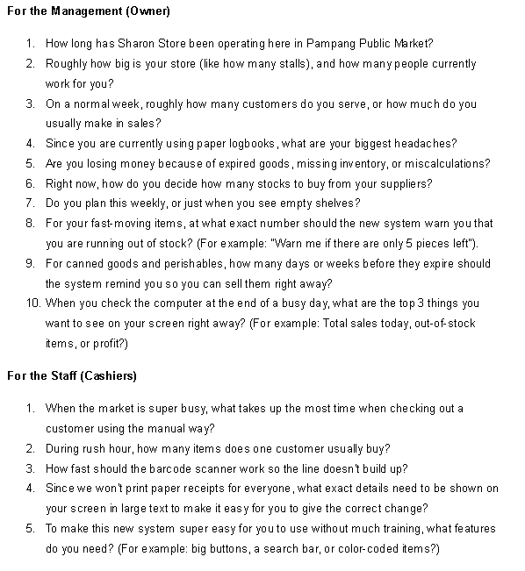
Appendix C: Interview Questions

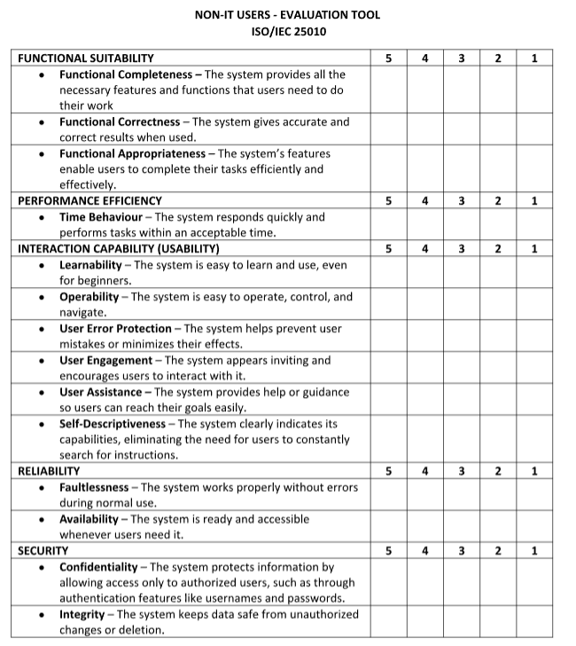
Appendix D: Evaluation Tool (Non-IT)

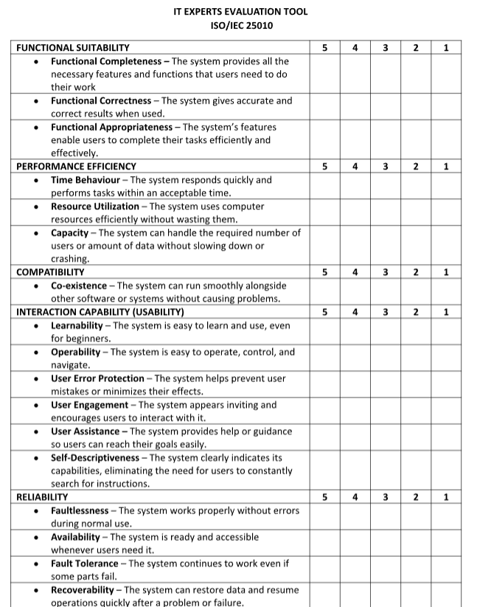
Appendix E: Evaluation Tool (IT Experts)

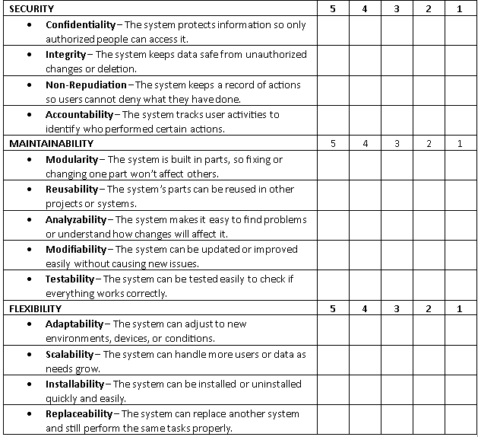

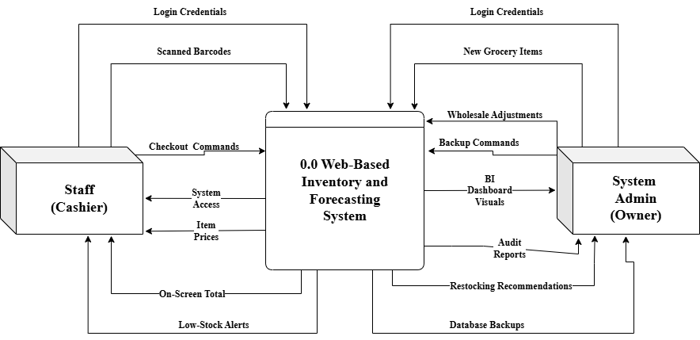
Appendix F: Data Flow Diagram Level 0
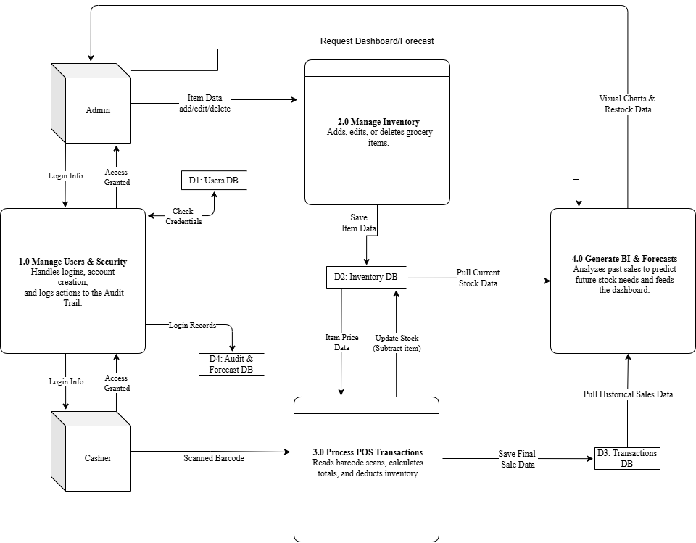
Appendix G: Data Flow Diagram Level 1

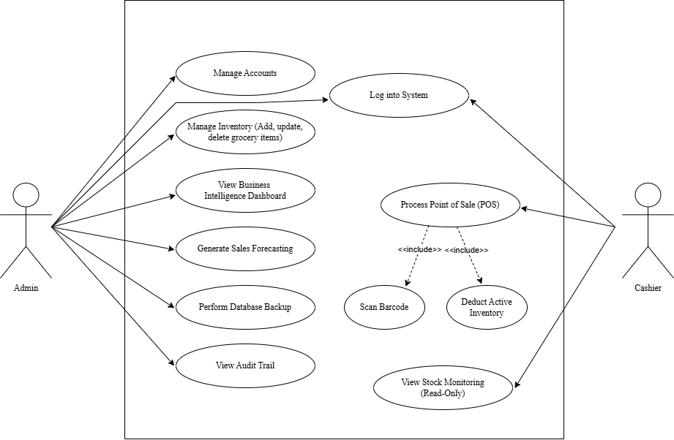
Appendix H: Use Case Diagram
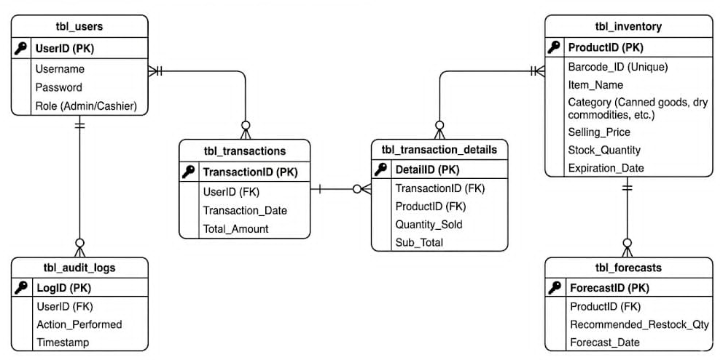
Appendix I: Entity Relationship Diagram
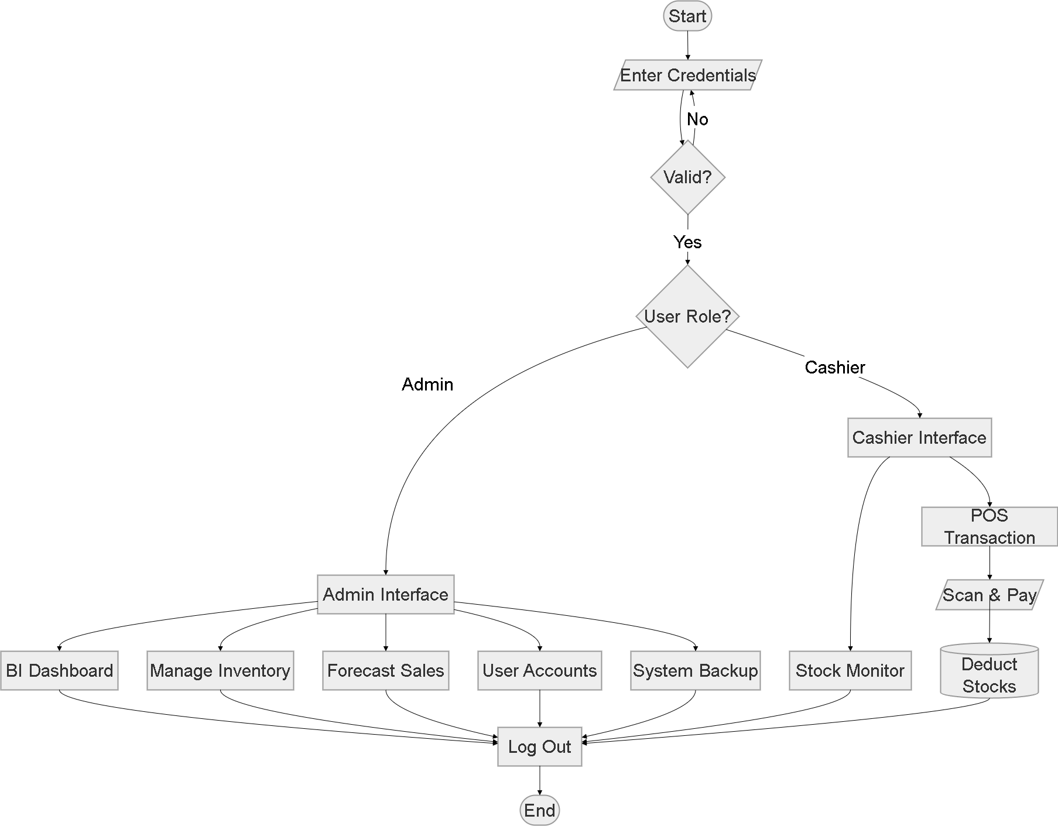
Appendix J: System Flowchart
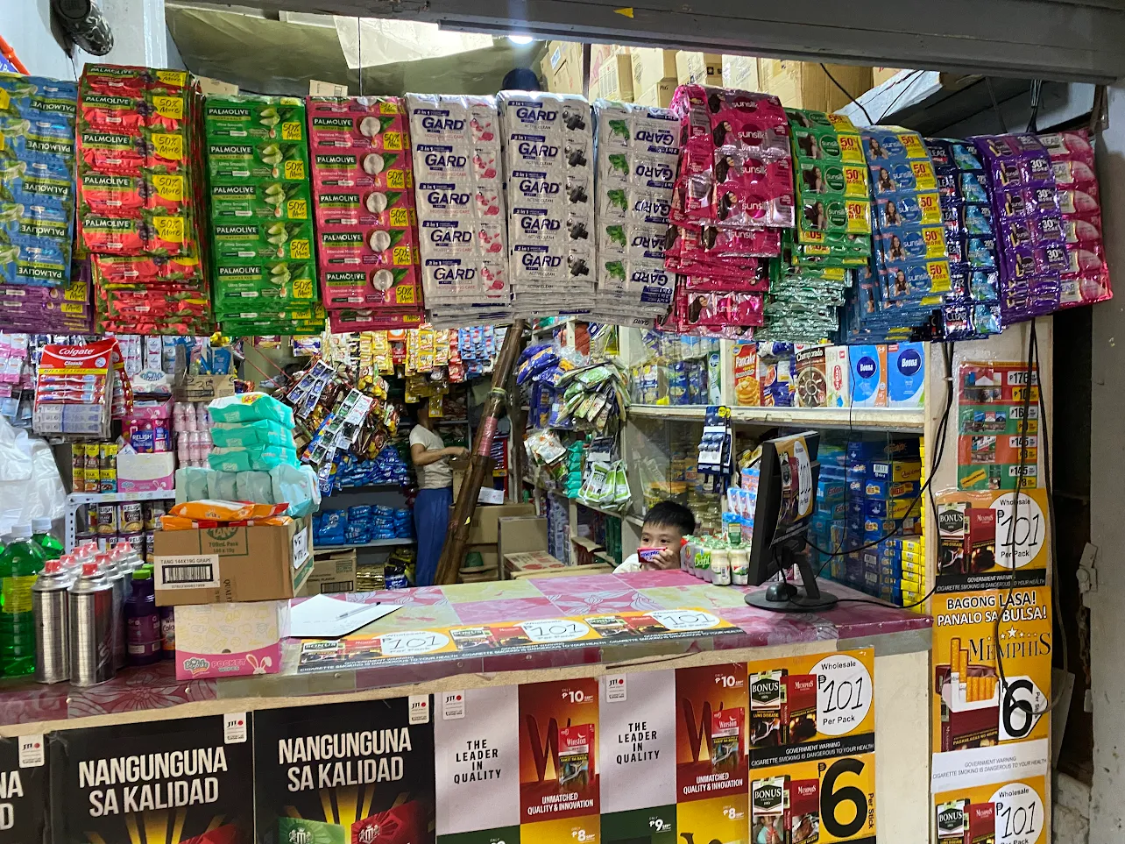
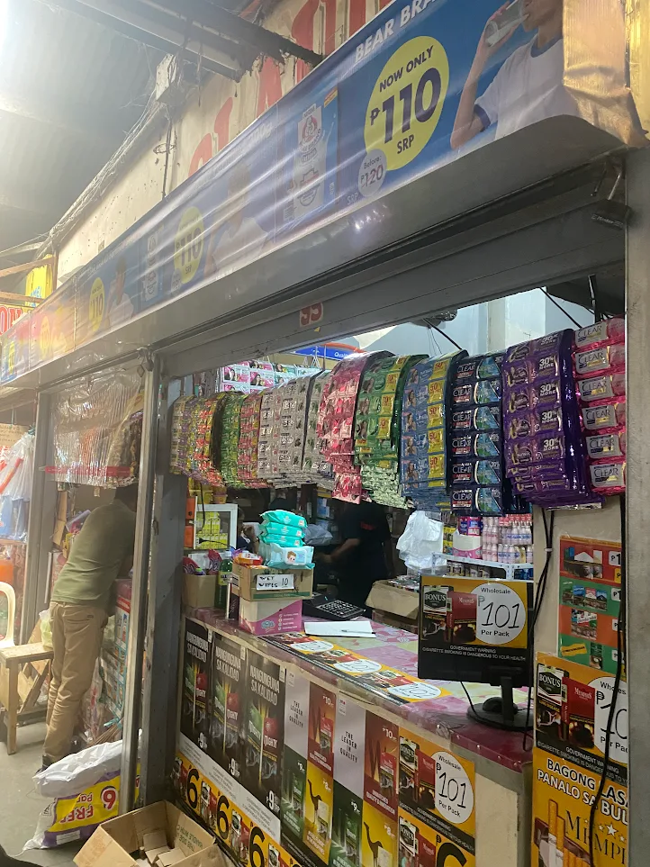
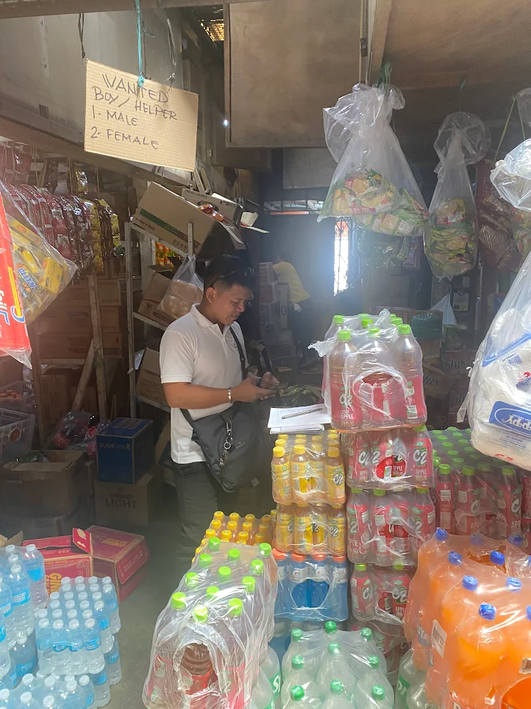
Appendix K: Documentation of the Research Locale.

